PROBLEM STATEMENT

|  |  |
| --- | --- |
| Project Title | News Tracker Application |
| Team ID | PNT2022TMID05721 |
| Team Members | Shivani.N  Akarshan.S  Surya Narayanan.R.U  Venkat Sowmya.R |

* A news-sharing app wants to help users find relevant and important news easily every day and also understand explicitly that the news is not fake but from proper sources.
* In today’s busy world , it is not possible to read the newspaper. By using this application, the user can access the news they are interested and get a quick peek for the day.
* There are multiple news-sharing apps used by a single user and are often spammed with notifications. There is also a lot of fake news which gets shared.
* This news tracker application helps the user to get all information about commodities, sports, technology, education etc.

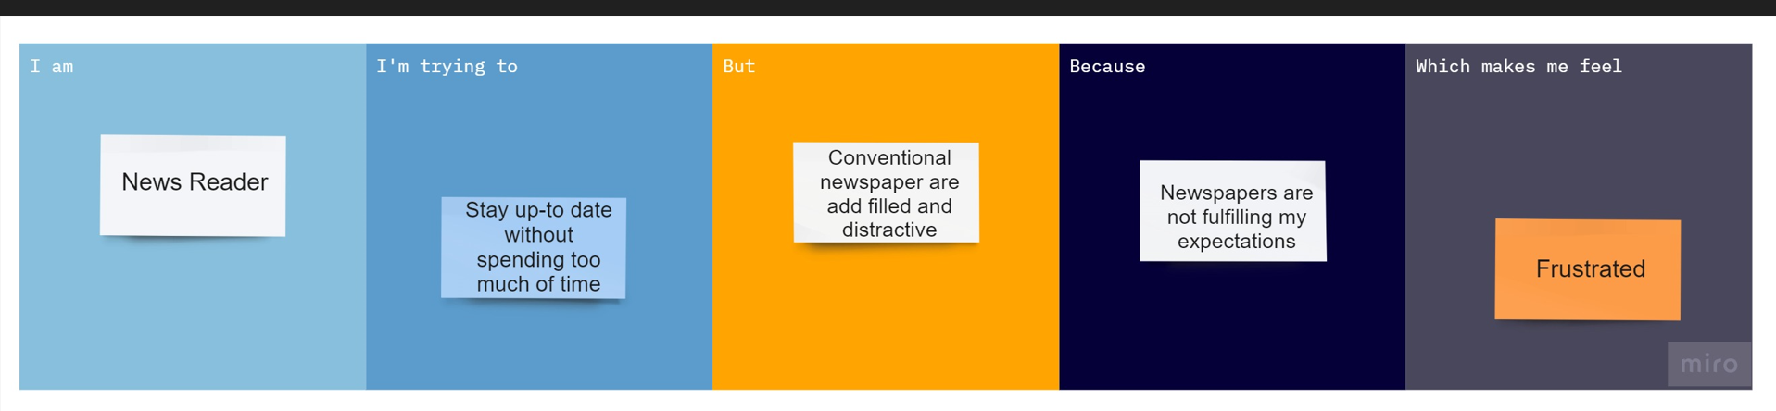

|  |  |  |  |  |  |
| --- | --- | --- | --- | --- | --- |
| Problem  Statement (PS) | I am  (Customer) | I’m trying to | But | Because | Which makes me feel |
| PS-1 | Student | Get the knowledge around the world on interested niche | TV and news application are distractive | Unnecessary Ads and news feed displayed | Frustrated |
| PS-2 | An HR of a IT industry | Get the right website or Application which update and notify me in every aspect. | Unable to find the right application or website. | It is challenging and hard to find single place to find the news. | I feel redirected to some other news which consumes a lot time by giving me irrelevant data. |
| PS-3 | Doctor | Innovate and Update in health sector | Unavailability of local and latest news | News feed loss context and unavailability of news searching for | Annoyed and Time consuming |
| PS-4 | Politician | To know the problems faced by common people and updates about opposite party | Unable to categorize the news | Unnecessary Ads and news feed displayed | Stressed |